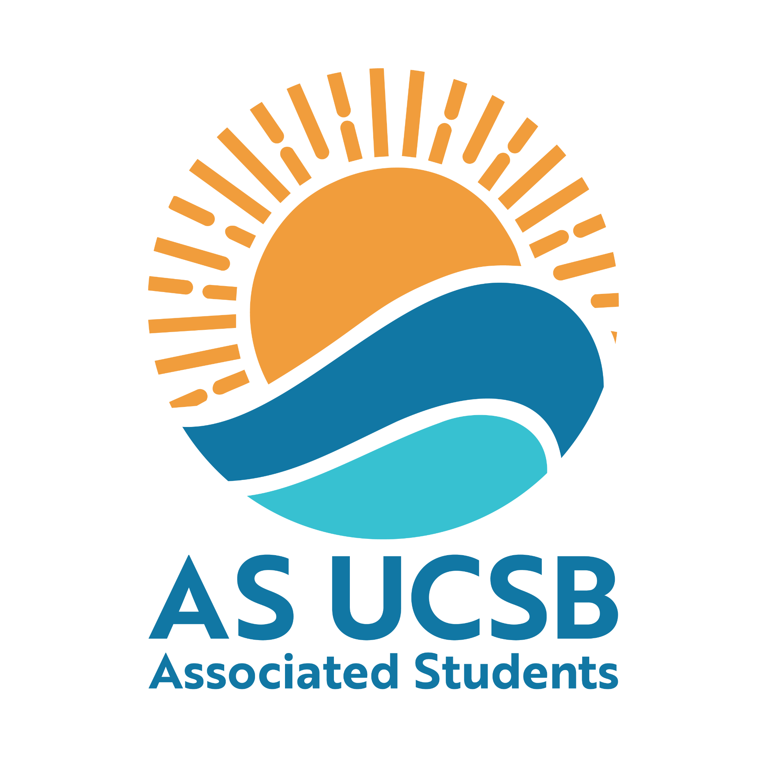

A.S. Committee on Committees Internal Chair

Transition Report

2026

Letter of Advice
Hi, welcome to CoC! I came in as Internal Chair for 2025-26 with a goal of building a strong foundation to get CoC up and running again after being pretty much inactive for many years. There's still a lot more to do, but hopefully this report gives you a strong starting point.
Three pieces of advice: find an ally in the Senate, invest in training and bonding a good team, and keep up with your email. CoC sits at the intersection of AS Admin, AS Exec, and BCUs. Our core role is bridging that gap through outreach, hiring, and keeping everyone informed on policies and procedures. A good Senate contact opens doors for collaboration, and staying on top of your inbox means you won't miss critical deadlines (like honoraria submissions) and can stay informed of updates to communicate to BCUs efficiently. Good team members will change your experience entirely, spend a lot of time training new people, encouraging them towards projects they’re excited about, and bonding the team in general.
Some wins our board had were nearly doubling our budget (previously not enough to cover honoraria, let alone outreach) and rebuilding the AS open positions website so students can find every opening in one place. I had zero training when I started and don't want you in the same position, so I made this passdown really detailed. Please reach out anytime with questions!
There will be a good amount of work to do over the summer to prep for the school year (Google Drive setup, hiring, building Exec contacts, etc.), make sure you sign up for summer honoraria so you get paid for it.

My contact: Lily Strange (818) 928-9302 lilystrange@g.harvard.edu

Purpose of the Position
- The Internal Chair runs all internal processes within CoC, including:
  - Updating the Google Drive
    - You can model this off of the 2025-26 CoC drive. The main components are:
      - Meeting minutes - you’ll need to make a document for each meeting, either weekly or you can add them for the entire quarter.
      - Training documents (update these as need be)
      - Move the open positions spreadsheet for 2026-27 to your new 2026-27 drive
      - Project folders (for chairs meeting, AS Jobs fair, etc, any projects you work on, keep them in easily findable places in your 2026-27 CoC drive so next years can refer to past projects, etc)
      - Interviews folder
        - Your vice chair will organize interviews, but keep them in one place in the drive so people can find interview notes
      - Social media folder for fliers and graphics
      - Transition documents folder
      - 2026-27 board contact sheet, see example here
      - Share your 2026-27 COC folder with COC AS emails and peoples personal emails!

  - Running meetings
    - You’ll need to schedule a good meeting time each quarter (I used when2meet and changed the time each quarter because people’s class schedules changed)
    - If you are not meeting in the CoC room (don’t need to reserve) you’ll need to make a weekly space reservation
      - For earlier meetings (5pm, etc) the CoC room is easy because most people are still on campus
      - If people’s availability constraints to meeting late, like 7pm, closer to IV was preferred by last year's board. We met in the Pardall Center, but they changed their policies recently so I’m not sure.
    - I liked to do question of the week (QOTW) for each meeting as a fun ice breaker to get to know people
    - After the meeting, move the minutes to the AS wide minutes folder. You can create a copy of the minutes doc click the … > organize > move > all locations > shared with me > A.S. Minutes (select the arrow to show sub folders) > to be approved (move here)

  - Honoraria
    - AS Admin / Finance staff will email you an honoraria form to fill out for all members
    - DO NOT FORGET TO DO THIS. I don’t think they allow retroactive / submission past the due date and chairs are responsible for submitting for the entire board

  - Organizing budget
    - 2026-27 budget is $17,600
    - Keep track of all expenses in a spreadsheet so you know how much of your budget remains
    - Honoraria is part of our budget!!! (450 for chairs + vice chairs, 300 all other positions)
    - See an example of how I did this here.
    - Sometime in winter quarter, information about budget presentations will be sent out, you’ll need to complete a form and attend a budget proposal meeting with Senate Finance Committee, this is how the next year’s budget is decided, keep an eye on your email

  - Training and mentoring new members
    - Make sure everyone has email access (if you have any trouble, submit a help ticket with AS help desk)
    - Make sure everyone has a keycard so they can access the CoC room (ask AS admin desk on the 2nd floor of the MCC for this)
    - Ensure graduating or resigning members update their passdown and give a passdown position to the new student in the position
    - Collect everyone's contacts on a contact sheet, make a group chat
    - Update the CoC website about us / contact page with names and emails

  - Tracking appointments and resignations
    - This is primarily the duty of the Internal Liaison, but you will be ensuring the form submissions for appointments and resignations are updated to the Appointments Tracker and a summary is sent to both the President’s office and the Senate, weekly.

Legal Code Duties
- Duties and responsibilities of the Committee Internal Chair:
  - Ensure that the responsibilities of the Vice Chair, Internal Liaisons, and Outreach and Recruitment Coordinators are met.
  - Report at three (3) Senate meetings each quarter including the Senate meeting immediately following a meeting of the A.S. Assembly.
  - Work with the Committee to schedule, advertise, and attend interviews of applicants for A.S. Committee positions (when needed) and student representative positions on Academic Senate and Administrative Advisory Committees.
  - Hold at least five (5) regular-posted office hours per week.
  - Must work with the A.S. Internal Vice President to put Committee appointments on the A.S. Senate agenda for ratification and submit relevant contact information for new appointees to the AS List Serves.
  - Report weekly to the Committee on Committees on which positions are open; track all resignations and removals from office.
  - Work with the chairs of A.S. entities to ensure necessary membership is met.
  - Ensure a positive climate is maintained in Associated Students through the direct oversight of internal climate projects and events that facilitate communication, teamwork, and leadership development.
  - Chair all of the Committee on Committees meetings with the External Chair.
  - Be responsible for setting weekly meeting times and locations for the committee, including gathering officer availability and coordinating space reservations.
  - Be an active member of the Office of the Internal Vice President.
  - Be a non-voting, Ex-officio member of all other A.S. entities.
  - Collaborates with the External chair to plan quarterly retreats for the Committee.
  - Be responsible for the fiscal management of the Committee and in conjunction with the External Chair, shall prepare the Committee’s budget for the following year.
  - Works in conjunction with the Committee on Committees Internal Liaison to run the AS Proxy Bank and conduct any necessary training.

Email
- as-internalchair.coc@ucsb.edu (password: vCk^2EjFpz=K)
  - Change your name, profile photo, and email signature
  - This is the account you use to log into slack
- as-coc@ucsb.edu (password: cocmainemail)
  - We don’t use this, but it would be good to check occasionally

Event Ideas / What I Did in the Role

Unfinished projects?
- Projects you didn’t get to finish and hope to be picked back up next year (include the contacts, documents, and background necessary to successfully carry it on)

Important Resources
- The AS Canvas is a great place to have new members trained (you’ll also have some mandatory trainings here)

Important Contacts
- Technically CoC’s AS advisor is Holly Dunn (hollym@as.ucsb.edu)
  - I’ve sent emails into the void to her honestly
  - You can try to establish contact but I have found it more efficient to just slack questions to different AS Admin
- SLACK!!!! ESSENTIAL!!
  - For AS policy or random very specific AS questions → Sean Lieberman is the expert for all things AS. He’s very busy, so only bother him if important
  - For general AS advising (you need to assign a Gateway cart, etc) →Kris Ehrman is awesome. He’s COSWB’s advisor (which I was part of) so I deferred to him for many questions because I had worked with him before.
  - For any financial questions → AS Finance Committee Chairs, Aryan Shukla, or Bryan Hernandez Feria
  - For any CoC website questions → Alex is great Alexander Herbaugh
    - (Slack is best for all of the above, but I linked their emails too)
  - For any tech needs: AS Help Desk
- For student contacts on Senate or Exec:
  - Evan Sussman the GOAT
    - He’s no longer in senate, but will be at UCSB next year and is a good contact for AS (especially
  - Vicky Ly (as-internalvp@ucsb.edu) 1 408 230 1990
    - Next year’s Interval Vice President
- We had great collaborations with the AS Careers Center as well, I would encourage you to do more projects with them. Here is who I worked with:
  - Alaina Hogeboom
  - LaTia Willis

